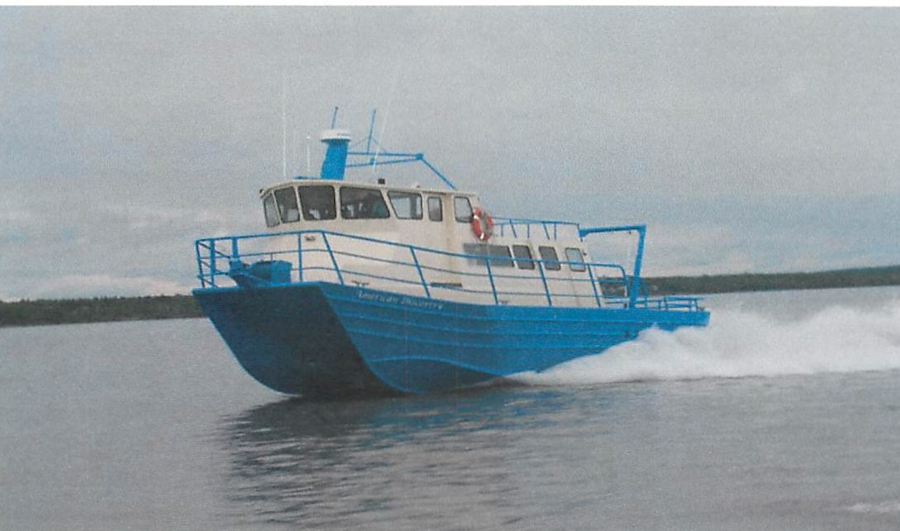
American Discovery
Vessel Information
Dispatch Port: Anchorage
Coast Guard Registry #: 1022089
Owner Name: Cook Inlet Tug & Barge Inc.
Home Port Address: P.O. Box 102120, Anchorage, AK 99510
Dispatch Phone #: (907) 277-7611
Tax ID #: 27-4236424
Contact: Katrina Anderson or Brad Kroon

Type of Vessel: Catamaran Crew Boat Gross Rated Tons: 11 GRT & 8 NRT
Hull Construction: Marine grade welded aluminum alloy plate Length: 39.9’
Breadth: 18.0’ Depth: 3.8’ Beam: 17’2”
Engine Type: Volvo 330 6 cylinder diesel Total Horsepower: 540HP
Auxiliary Power: Northern Lights Lugger 6 kW diesel generator Fuel Capacity: 2- 200 gallon tanks
Water Capacity: 150 gallons Passenger Capacity: 31

